BookList

User Guide

Table of Contents
Last Update: 23.05.2024

Starting with BookList 3
Search & Find 4
Simple Search 4
Advanced Search 5
Limit to 6
Location & Access 7
Books in the Library 7
How to Find 7
Place a Hold 9
Books at the Research Groups 9
eBook Collections 10
Personal Account 12
Self Checkout (HowTo borrow books) 13
Purchase Suggestion 15

BookList (koha.ista.ac.at) is the library catalog containing an increasing number of books and eBooks available at ISTA. You will find all book items offered by the library for general use, but it also includes numerous books held by the research groups of ISTA.

At the moment the library offers around 2.600 books to lend in the fields of biology, mathematics, physics, computer science etc. Library books are freely accessible 24/7 at our physical library located on the ground floor of Sunstone Building. Apart from reference books you can borrow these books by using our Self Checkout System. BookList also lets you administer your library account. It shows you the books you have recently borrowed, allows you to renew your borrowed items and to put books on hold.

Besides the physical books you can also search the catalog for more than hundred thousand of eBooks licensed for ISTA employees. The catalog leads you directly to the publisher where you can read or download the items.

The following user guide gives you an overview how to use BookList.

Starting with BookList

You reach the library catalog at koha.ista.ac.at/.

After logging in with your ISTA credentials (and token), you can, for example, start a simple search or check out books to your personal account at BookList. A list of links refers to other library services.

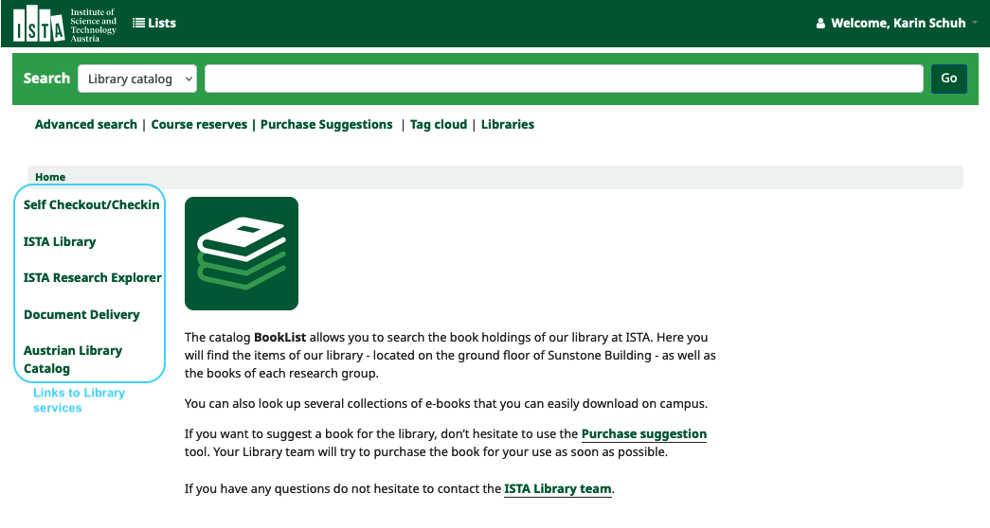

Search & Find

Simple Search
For searching items in the catalog just visit koha.ista.ac.at/. On the home page, you will find a search bar that allows you to either search the entire library catalog or use the drop-down menu with some specific fields such as title, author, etc.

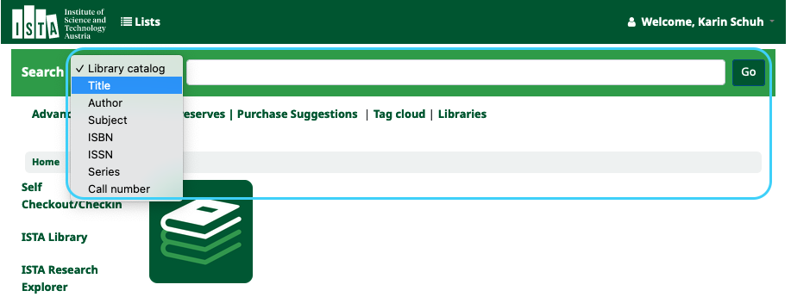

The search will result in a list of books and eBooks available at ISTA.

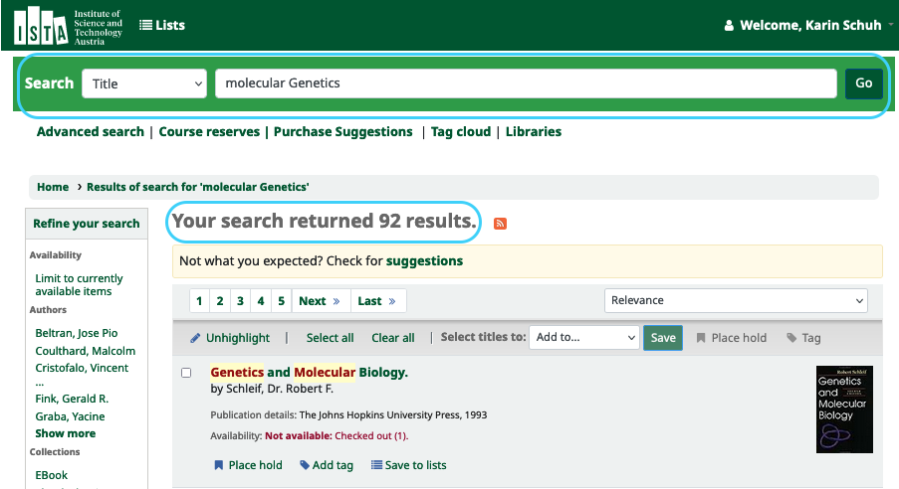

Advanced Search
If you'd like to make a more precise search you can use the “Advanced search”. A link at the homepage leads you there.

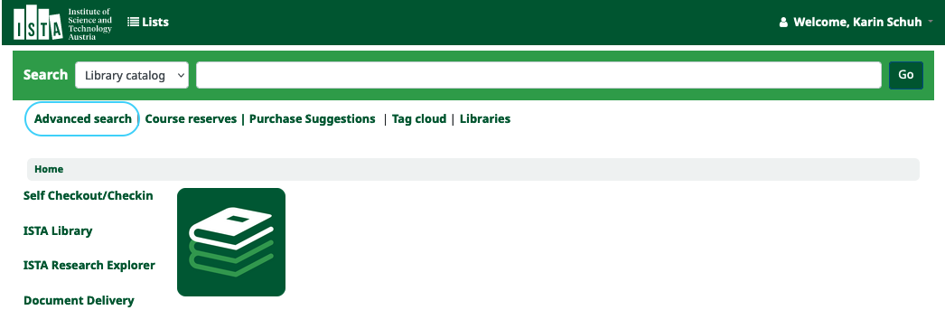

Choose a category you'd like to search for (e.g. title) and combine it with an additional category (e.g. author).

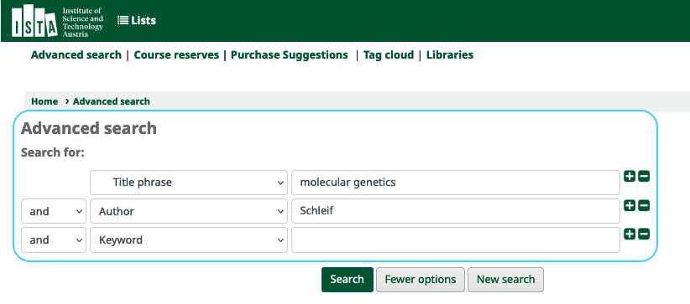
You can also reduce the hit list by item type (eg. Book, eBook, etc.)

Limit to
You can refine your search results after receiving a hit list. Different categories for limiting the number of results are listed in the left column:

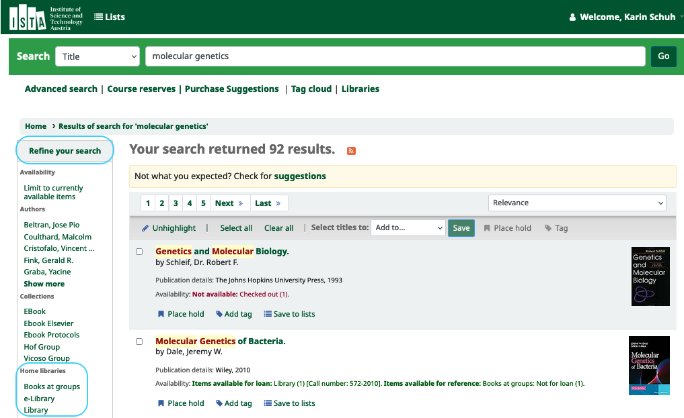

Home libraries:
“Books at groups” lists books of different research groups. These items are not intended for public use, but you can always contact the group.
“e-Library” contains our licensed eBooks
“Library” stands for all books of the publicly available library, you can check out these items

Item types:
“Book” includes all physical items
“eBook” contains licensed electronic books

Several different limitations like “currently available items”, “Authors”, Series etc. are possible as well.

Location & Access

Books in the Library

How to Find
To locate a book on the library shelves, please refer to the classification system, which consists of three-digit numbers (e.g., 572) and the copyright year tagged on the spine of the book. The number and the year are also shown in the catalog entry of each book at the field “Call number”. Each number stands for a special field like “00x” for Computer Science”, “512” for “Algebra”, or “570” for “Life sciences”.
To make the search easier for you, the main fields (categories) are marked with different colors in the library so the searching is as quick as possible.

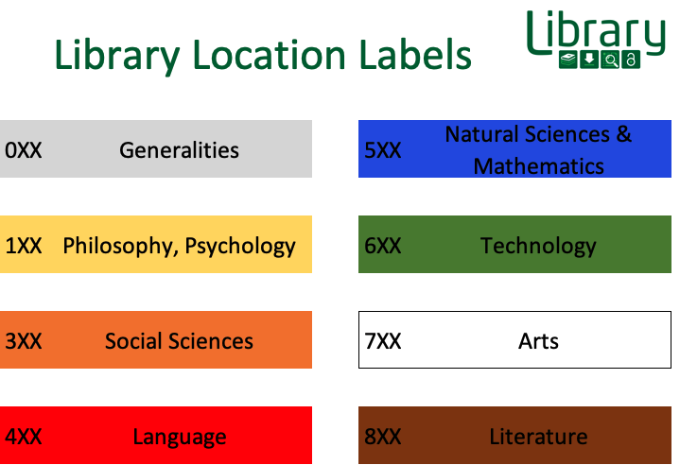

The following screenshot shows different information about availability of books in the library and on campus within the research groups.

Catalog view:

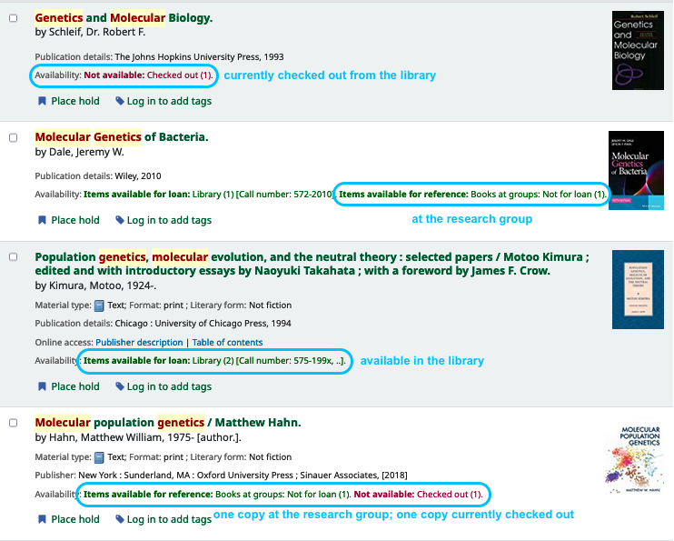

Single item view: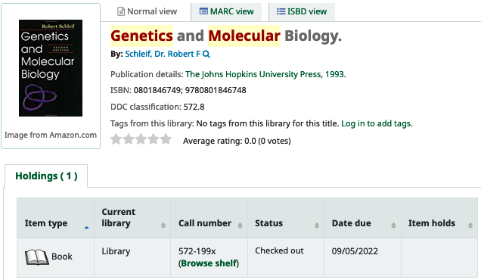

Place a Hold
If a book isn't available at the moment, you can reserve it by pressing the button “Place hold”.

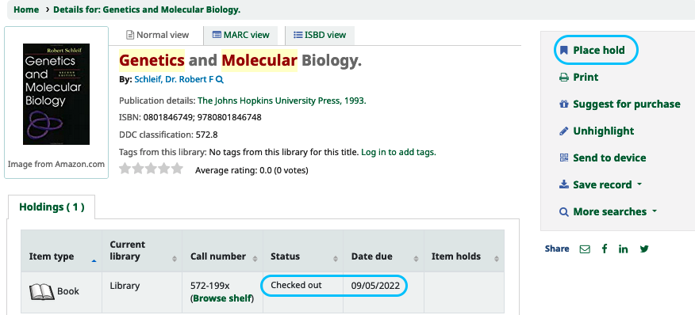

Books at the Research Groups
Books held by research groups are listed in the catalog as well. Not all of the books of a research group are necessarily registered.

Books of research groups are listed as “Books at groups” in the field “Current library”. The “Collection” field refers to the group. These books cannot be borrowed from the library, but you can contact the Research Group.

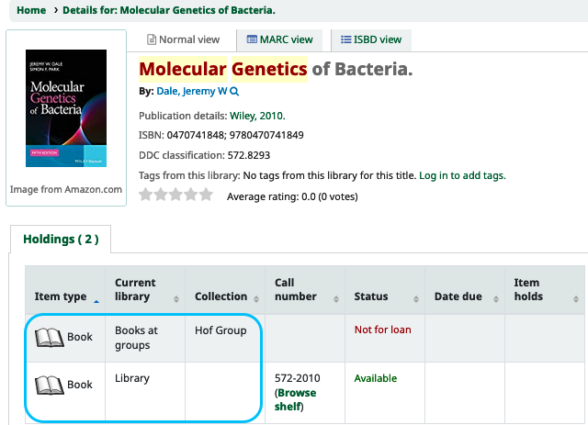

eBook Collections

ISTA is licensing more than hundred thousand of eBooks. To reduce your hit list to eBooks please follow the instructions at the chapters Advanced Search and Limit to.
If you'd like to access an eBook please follow the link at the field “Online Access”. You can find this link both in the hit list display or the single item display.
You can find a list of all accessible collections here https://ista.ac.at/en/research/library/find-read/ebooks/

Hit list display:
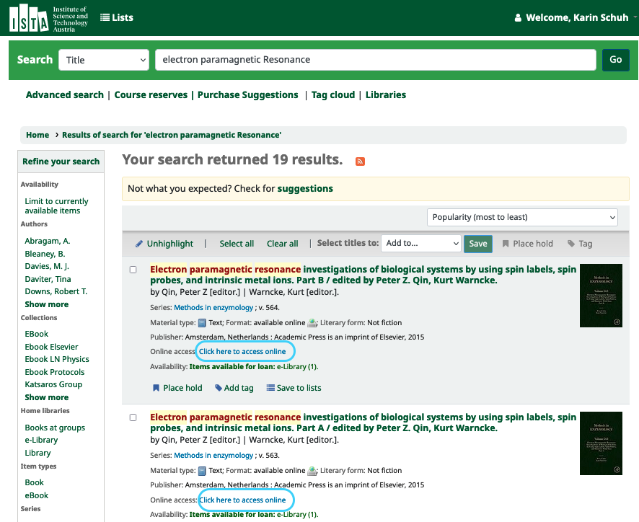

Single item display:
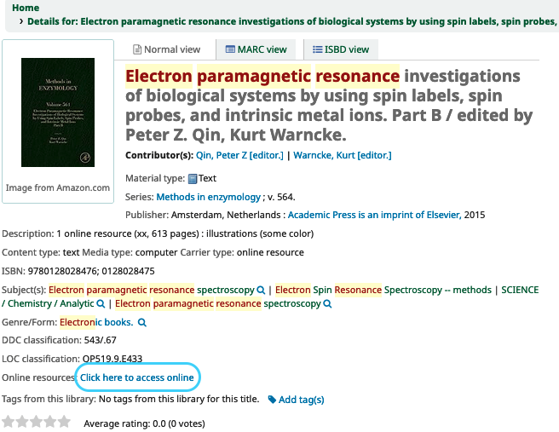

Personal Account
Everybody at ISTA has an own account for BookList. It is activated with your first login with your ISTA credentials (username, ISTA password, Token).

To access your account, click on one of the highlighted links.
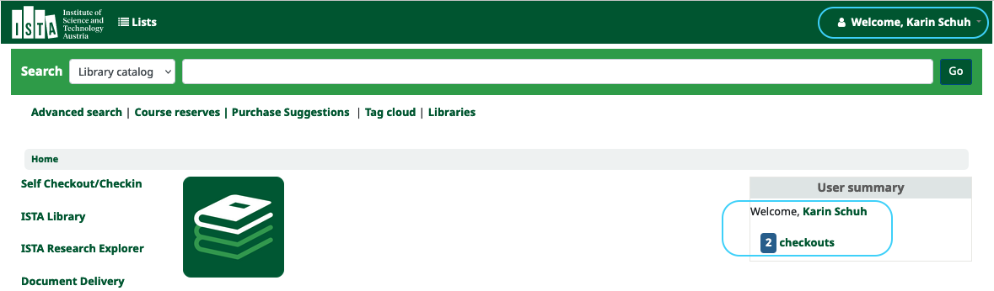

Within your account you can check the status of books you have on loan and renew books before the due day if nobody is waiting for it. All books are automatically checked out for 2 months.

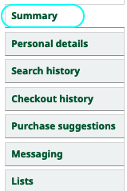
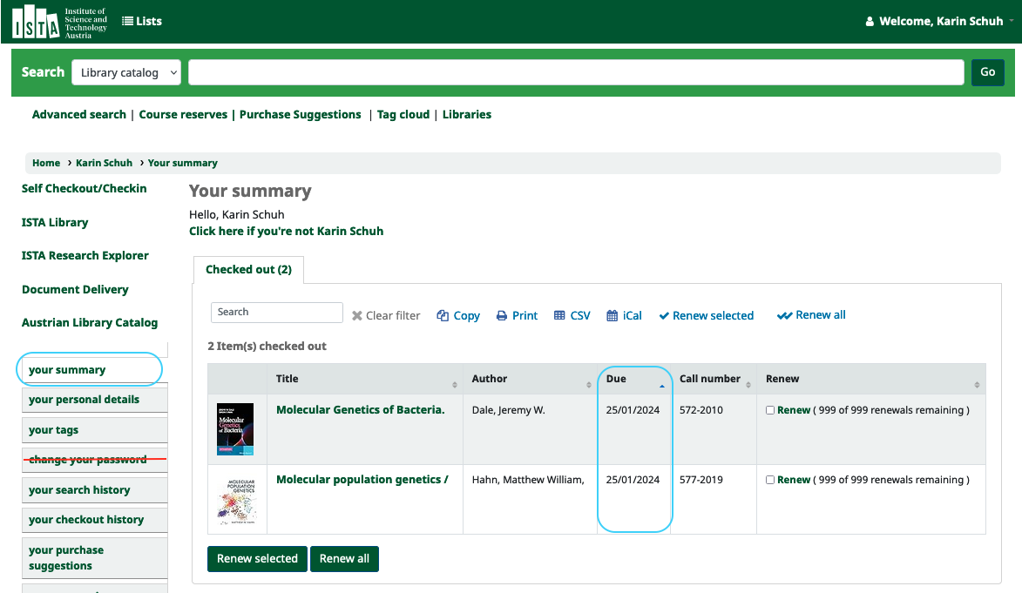

Here you can also create a private list or view public lists.

Self Checkout (HowTo borrow books)
If you are an employee at ISTA and would like to check out a book from the library, please use the self-checkout tool on the computer in the library or on your personal computer. Please note that the tool is not available for external users.

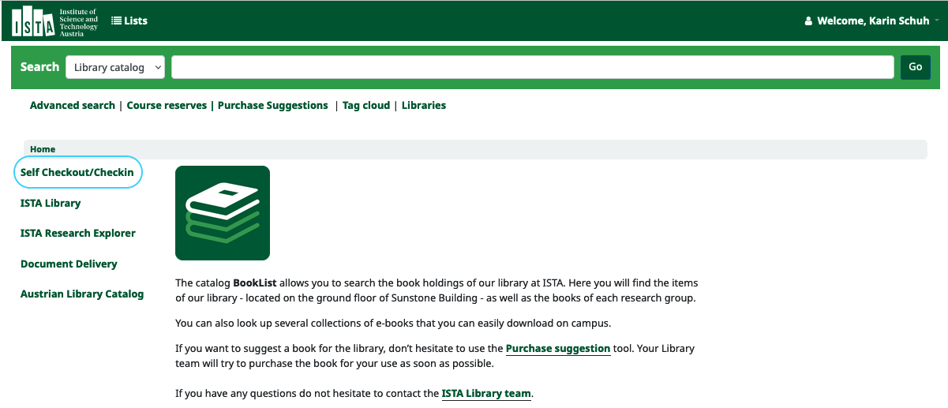
You are allowed to keep a book for 2 months, if you still need it you can prolong this period.

To check out a book enter or scan the barcode and click on “submit”:

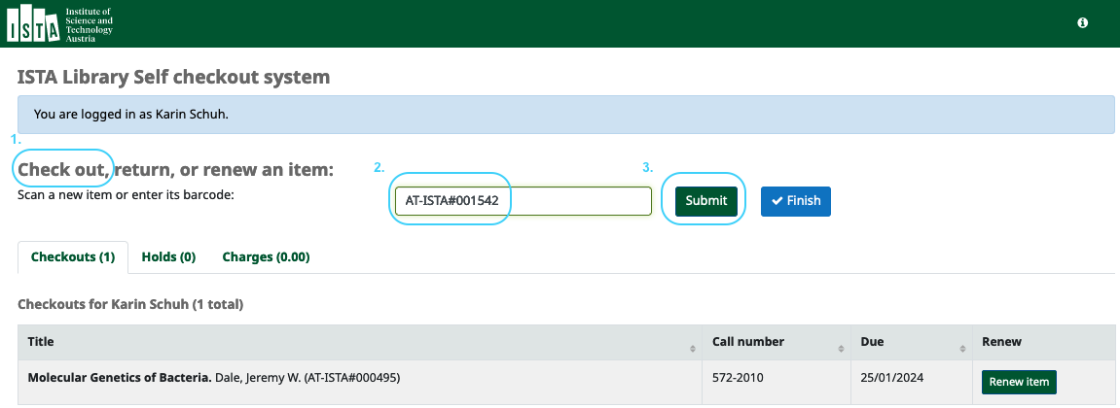

Please note: The "Finish" button is currently not working :(

To return a book, enter or scan the barcode and click on "submit" again. The following page appears:

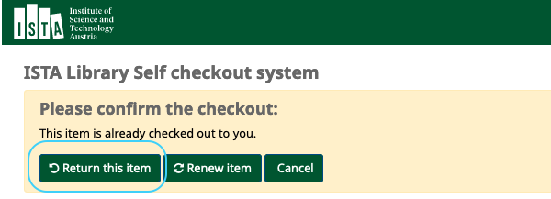

Click on "Return this item" to return the book.

You can renew books either in the self-checkout module or in your account under "your summary".
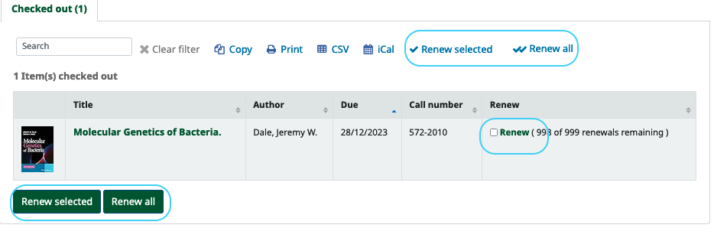

Purchase Suggestion
If you want to suggest a new book for the library, please use the “Purchase Suggestions” tool.
Follow the link “Purchase suggestions” on the home BookList page.

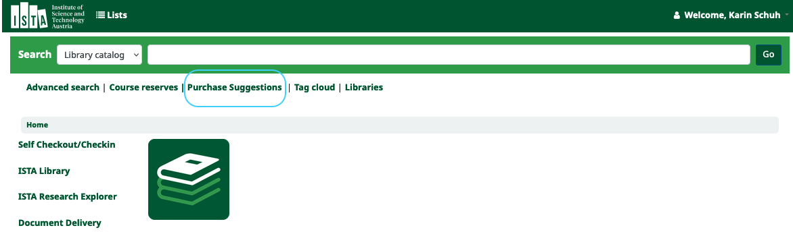

Please click on the link “New purchase suggestion.” Just enter the title and some additional information or notes and click on “Submit your suggestion”. The library will let you know whether the book will be purchased. You will also receive a message when the book has arrived. Additionally, you can follow the status of your suggestion at “your purchase suggestion”.

